WEEK 1:

**Exercise 1: Implementing the Singleton Pattern**

**Logger.java**

package SingletonPatternExample;

public class Logger {

private static Logger *instance* = new Logger();

private Logger() {

System.***out***.println("Logger instance created");

}

public static Logger getInstance() {

return *instance*;

}

public void log(String message) {

System.***out***.println("[LOG]: " + message);

}

}

**Main.java**

package SingletonPatternExample;

public class Main {

public static void main(String[] args) {

Logger logger1 = Logger.*getInstance*();

Logger logger2 = Logger.*getInstance*();

logger1.log("This is the first log message.");

logger2.log("This is the second log message.");

if (logger1 == logger2) {

System.***out***.println("Both logger instances are the same. Singleton confirmed!");

} else {

System.***out***.println("Different instances found. Singleton implementation failed!");

}

}

}

**Output:**

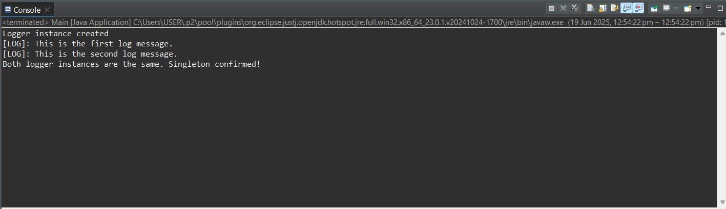

**Exercise 2: Implementing the Factory Method Pattern**

**Document.java**

package FactoryMethodPatternExample;

public interface Document {

void open();

}

**DocumentFactory.java**

package FactoryMethodPatternExample;

public abstract class DocumentFactory {

public abstract Document createDocument();

}

**ExcelDocument.java**

package FactoryMethodPatternExample;

public class ExcelDocument implements Document {

*@Override*

public void open() {

System.***out***.println("Opening Excel document...");

}

}

**ExcelDocumentFactory.java**

package FactoryMethodPatternExample;

public class ExcelDocumentFactory extends DocumentFactory {

*@Override*

public Document createDocument() {

return new ExcelDocument();

}

}

**PdfDocument.java**

package FactoryMethodPatternExample;

public class PdfDocument implements Document {

*@Override*

public void open() {

System.***out***.println("Opening PDF document...");

}

}

**PdfDocumentFactory.java**

package FactoryMethodPatternExample;

public class PdfDocumentFactory extends DocumentFactory {

*@Override*

public Document createDocument() {

return new PdfDocument();

}

}

**WordDocument.java**

package FactoryMethodPatternExample;

public class WordDocument implements Document {

*@Override*

public void open() {

System.***out***.println("Opening Word document...");

}

}

**WordDocumentFactory.java**

package FactoryMethodPatternExample;

public class WordDocumentFactory extends DocumentFactory {

*@Override*

public Document createDocument() {

return new WordDocument();

}

}

**Output:**

